

RiverStone Group

Commutation Tool

Mini Design

Version ID Date: 2015-06-12
Version ID: 1.0.0

Revision History
Version | Date | Author | Description
1.0.0 | 2015-06-12 | Scott Marcus | Initial Release
Table of Contents
1. Summary 5
2. Requirements 6
3. Functional Design 7
3.1 Selection of one or more Comm ID’s 7
3.2 Generation of an Exposure Spreadsheet 8
3.3 Generation of a Contract Spreadsheet 8
3.4 Generation of an Open Balance Spreadsheet 8
3.5 Viewing a list of Comm ID rows for selected Comm ID’s 9
3.6 Assigning a row to a CommID 9
3.7 Clearing a Comm ID 10
3.8 Creating a new Comm ID 10
3.9 Searching for a Comm ID 11
4. Database 12
4.1 Tables 12
4.2 Views 12
4.3 Referential Integrity 12
4.4 Diagram 13
5. Technical 14
5.1 Concurrency 14
5.2 Design Patterns 14
5.3 Platform 14
5.4 Deployment 14
6. Security 15
6.1 Roles 15
6.2 Audit Trail 15
6.3 SSO / Authentication 15
6.4 Authorization 15
7. Assumptions and Risks 16
7.1 Assumptions 16
7.2 Risks 16

Summary

Operations has developed an Access tool for the Commutations team that allows for the generation of three different spreadsheets Exposure, Contract and Open Balance based on the selection of one or more Commutation ID.

A Commutation ID is a user chosen name used to tag one or more Parties used to filter the data for the three spreadsheets.

In order to allow this functionality for people in remote offices and those who do not have Access it was decided to publish this functionality as a web page.

This web page is a temporary solution expected to last approximately a year, at which point it will no longer be needed based on new functionality coming online from other tools.

Requirements

- Operate as a web page
- Allow multiple concurrent users
- Work with the existing tables and views
- Allow for the selection of multiple CommID’s
- Create three different spreadsheets for Exposure, Contract and Open Balance based on three views
- Generate spreadsheets in XLSX (Excel) format with a shaded and frozen header row
- Large spreadsheets (25,000 rows) should be generated in a reasonable amount of time
- Allow the user to see which rows of the _CommutationID table are assigned to the selected CommID’s
- Allow the user to clear a row in _CommutationID so that it is no longer set to any CommID
- Allow the user to set a row in _CommutationID to a particular CommID
- Allow the user to search the _CommutationID table by following columns:
Party Key
Portfolio CD
Sapiens Internal Reco CD
Reco Desc
FEIN ID
System of Record
- Allow the user to create a new CommID with Comm Name
- Authentication / SSO based on IIS windows security
- Access will be limited based on membership in one or more AD groups

Functional Design

Selection of one or more Comm ID’s
Area for selection shown in purple
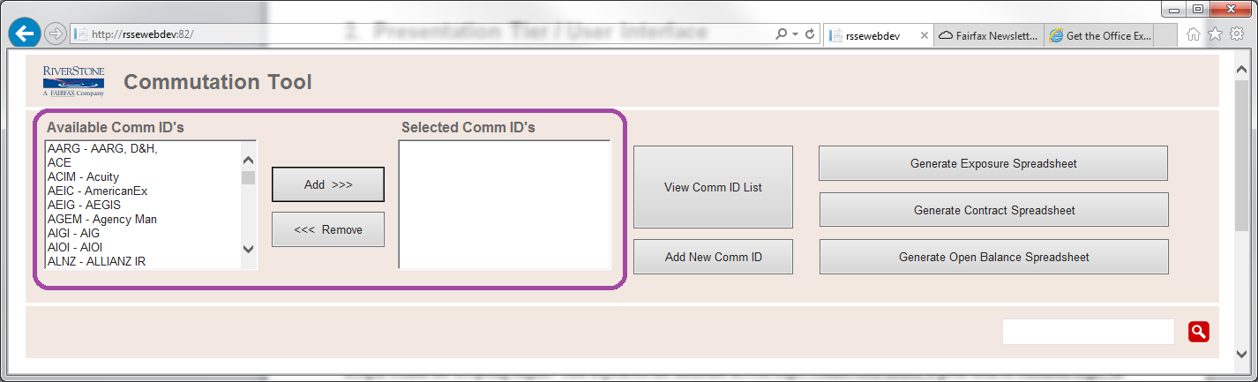

Select a Comm ID by choosing on in the Available listbox on the left and pressing the Add button
Remove a Comm ID from your selection by selecting from the Selected listbox on the right and pressing Remove
Note: This does not make any changes to the database, it is just for the purpose of choosing a list of Comm ID’s

After three Comm ID’s have been selected
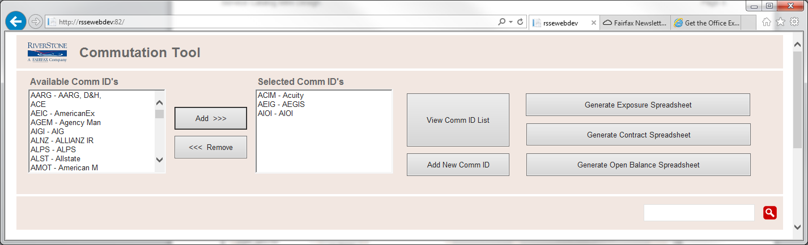

Generation of an Exposure Spreadsheet
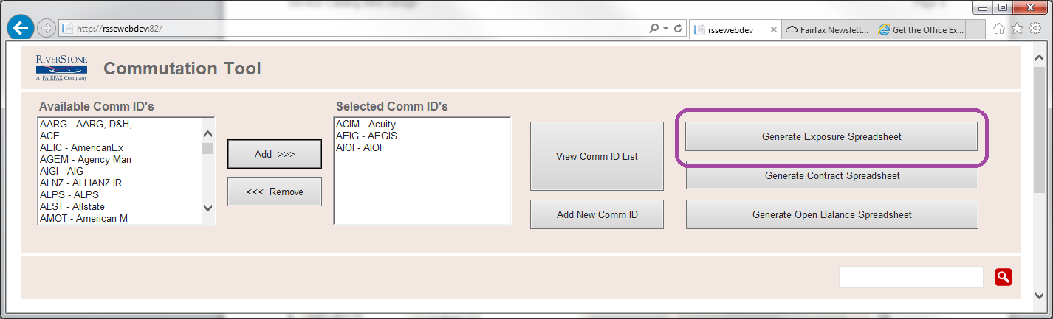

Generation of a Contract Spreadsheet
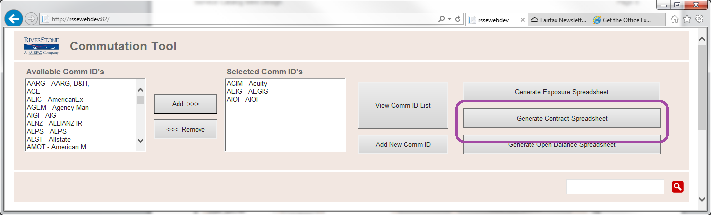

Generation of an Open Balance Spreadsheet
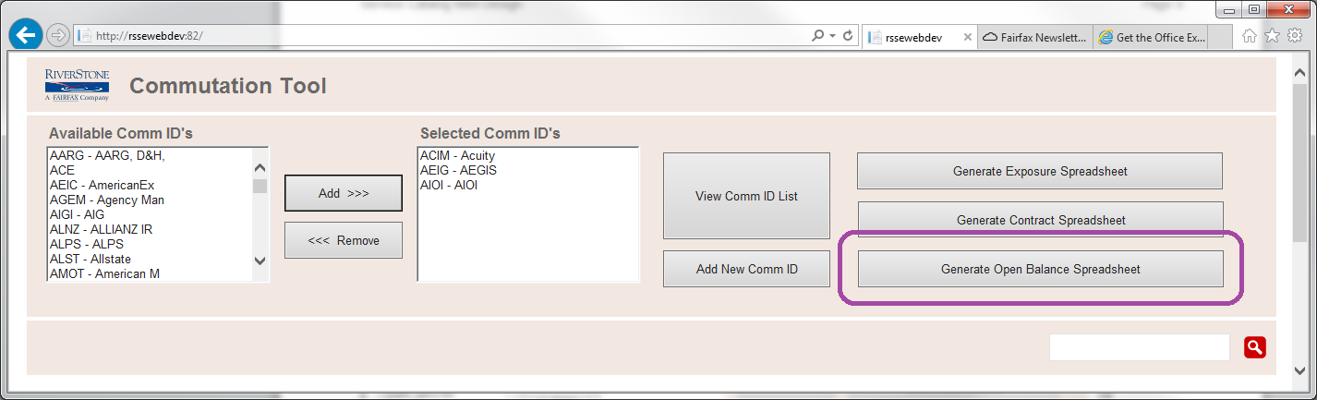

Viewing a list of Comm ID rows for selected Comm ID’s
Note: Clicking on a row will select it, indicated with a blue highlight
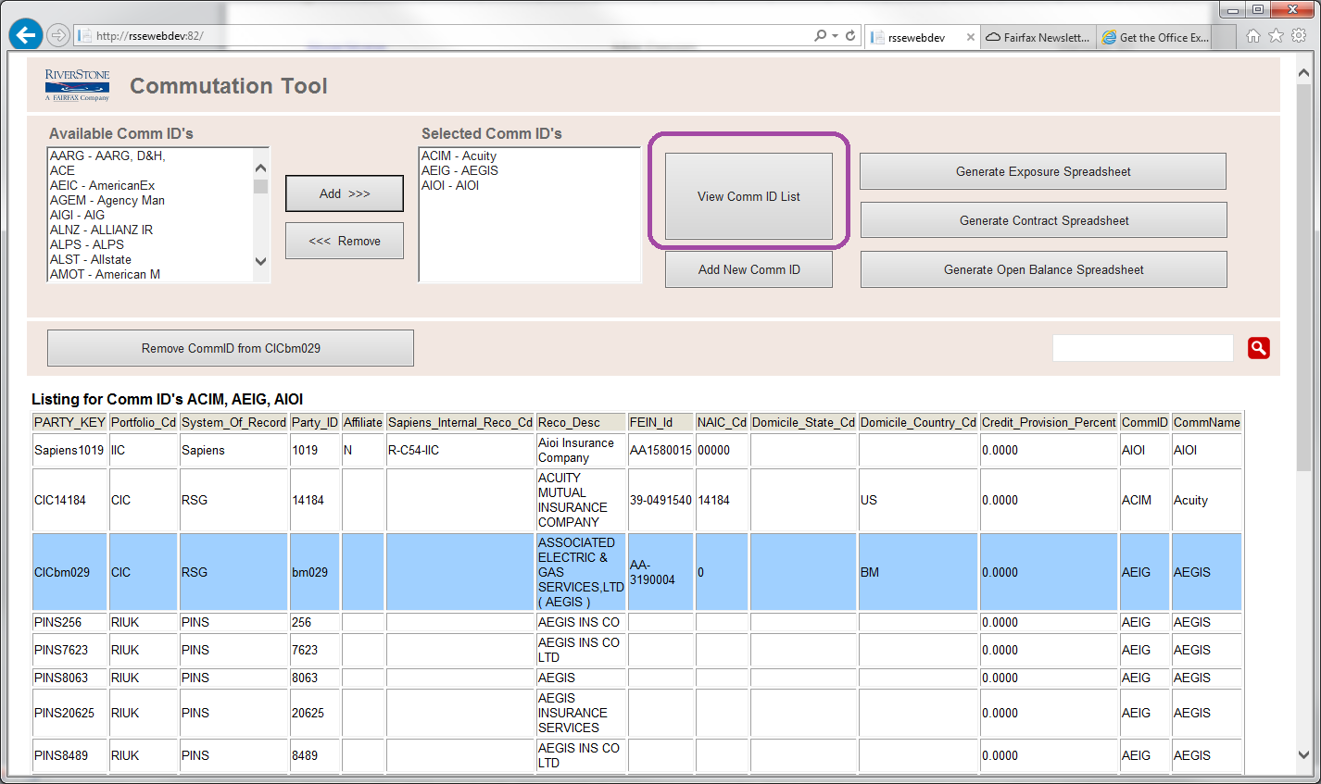

Assigning a row to a CommID
Clicking a selected CommID on the right will cause a Set button to appear for that Comm ID.
Pressing the button will assign the selected row to the indicated Comm ID
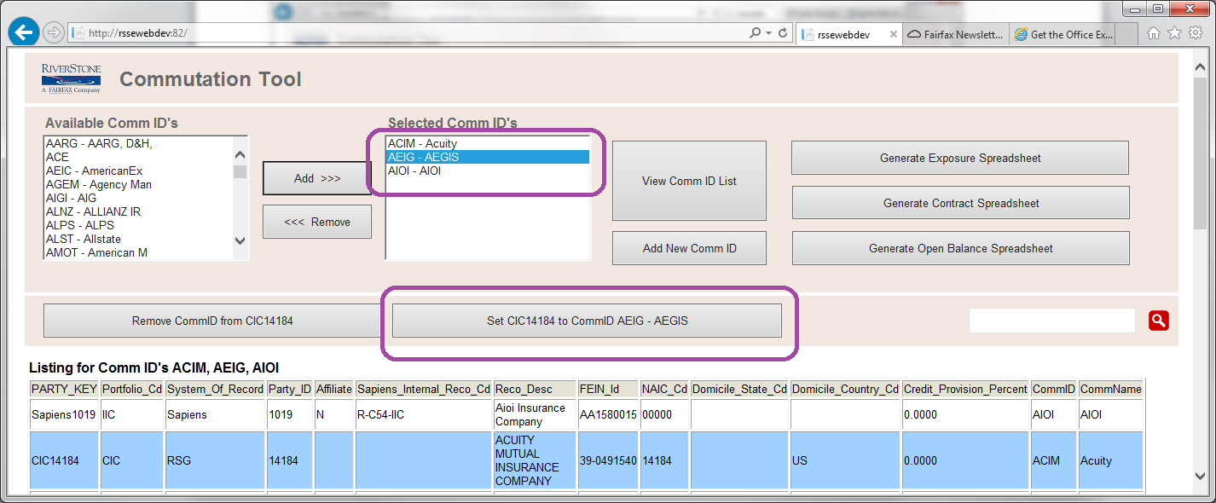

Clearing a Comm ID
Use the Remove CommID button
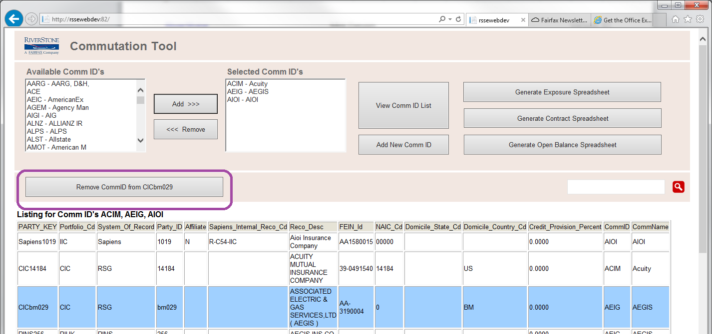

Creating a new Comm ID
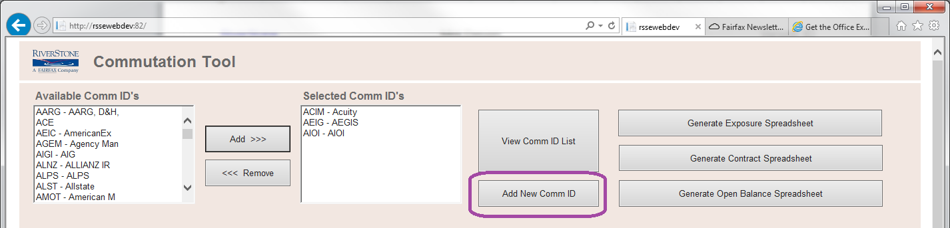

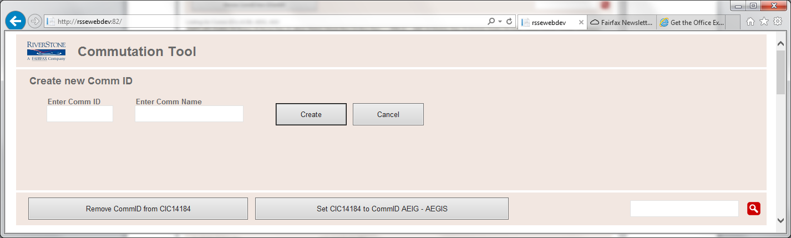

Searching for a Comm ID
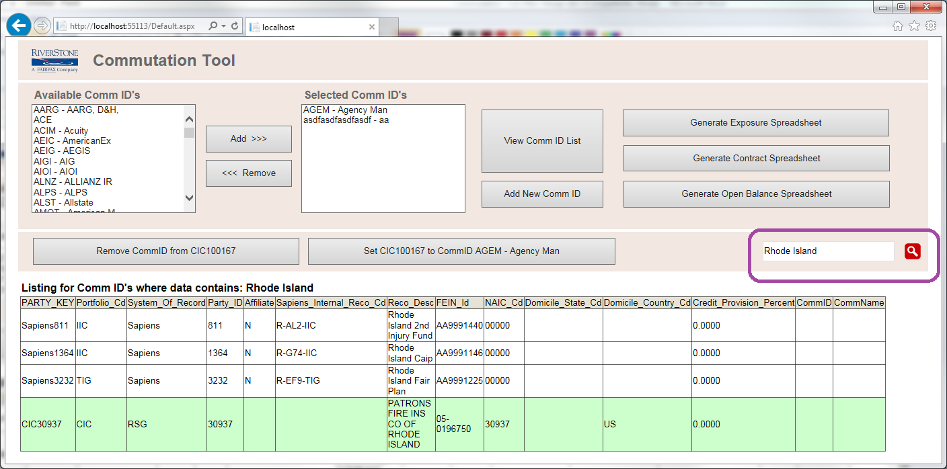

Database

Tables
Table Name | Function
_CommutationContract | Commutation contract data by party
_CommutationExposure | Commutation exposure data by party
_CommutationID | List of party ID’s with tags (bookmarks) called CommID’s

Views
Procedure Name | Function
CommutationContractView | View joining _CommutationContract and _CommutationID
CommutationExposureView | View joining _CommutationExposure and _CommutationID
CommutationOpenBalanceView | View joining _CommutationExposure and _CommutationID where the sum of BALANCE, CURRENT_BALANCE_UNBILLED and CURRENT_BALANCE_UNDER_THRESHOLD round to 0.

Referential Integrity
The database has no enforced referential integrity or key relationship between the tables.

Diagram
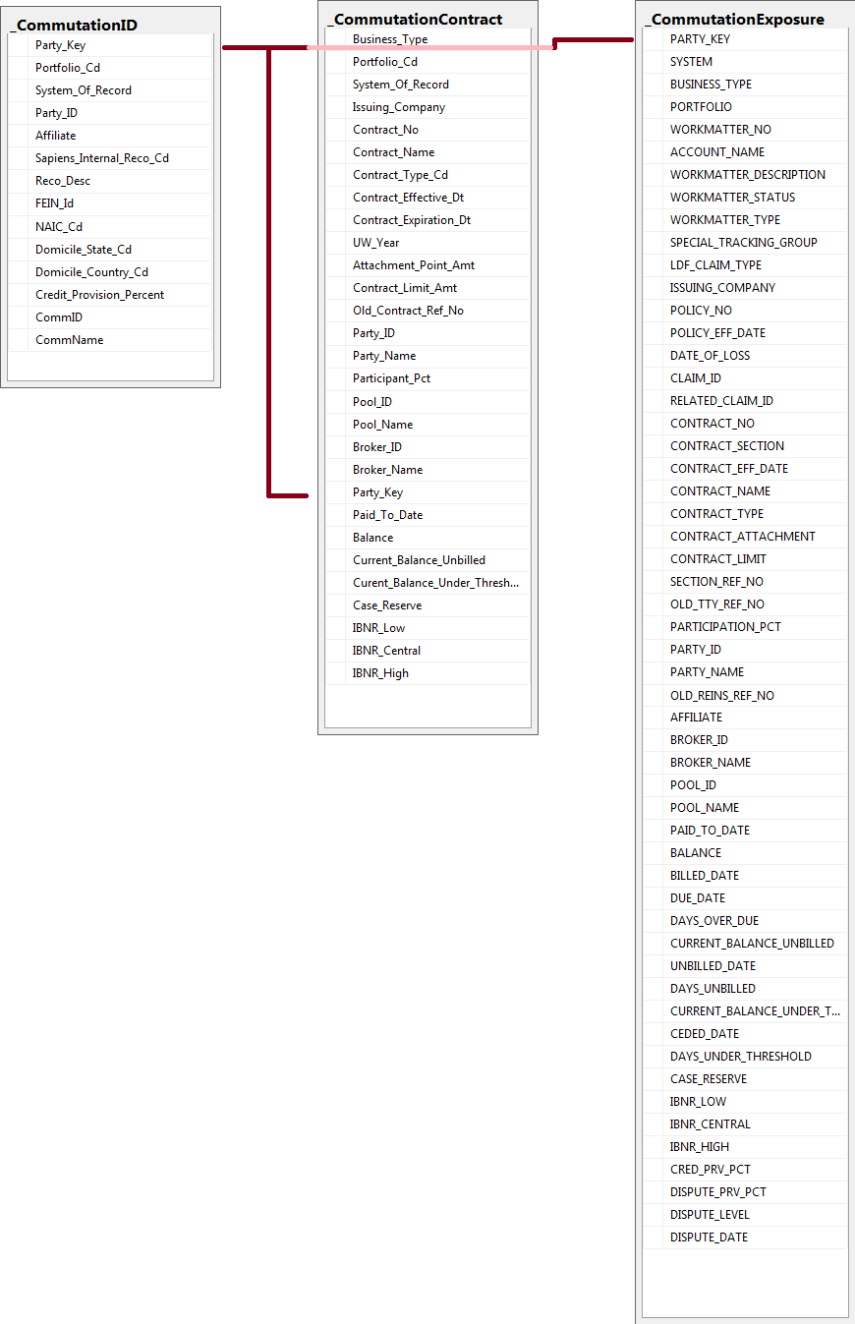

Technical
The Commutation Tool will use a traditional 3 tier infrastructure deployment consisting of development, testing, and production environments. Each tier utilizes a database and application server. The database for the development and test tiers will most likely be a single shared instance.

Concurrency
The Commutations Tool is designed to allow n number of users at a given time. It’s a web service orientated architecture which only keeps connections open during the life of a service call.

Design Patterns
The Commutations Tool uses these design patterns:
Factory: To create UI objects
Lazy initialization: For enhanced performance
Object pool: For enhanced performancy and memory usage

Platform
This project is developed using the following Microsoft technologies that already exist in the RiverStone environment:
- ASP.Net Framework 4.5
- C# programming language
- Open XML
- SQL Server 2008 R2 database

Deployment
Deployment of the Commutation Tool web site will be done via Click Once.
Deployment of data from OPSDW (staging) -> SQLDEV2012R2 (dev / test) -> SQLPROD2012R2 (prod) will be done by an SSIS package that truncates and copies the three tables.
For disaster recovery and failover, please reference the current RiverStone documentation of such for the production environment.

Security

Roles
There are no roles or levels of access. Anyone with access can perform all functions.

Audit Trail
There is no audit trail.

SSO / Authentication
Single Sign On is provided by Windows Authentication in IIS

Authorization
A list of one or more AD groups in the web.config file will define users who are authorized.

Assumptions and Risks

Assumptions
We are assuming the .net OpenXML namespace has the performance we need, and can write Excel sheets of the size we need.

Risks
A given spreadsheet may become too large to transport as a file over http.
Document Review and Approvals
We have reviewed and hereby approve the Technical Design Document.

Marc Vance (Software Development) Date

Amy Shakow (Vice President BIU) Date

Ed Jervey (Department Head) Date

Steve Maienza (CIO) Date

